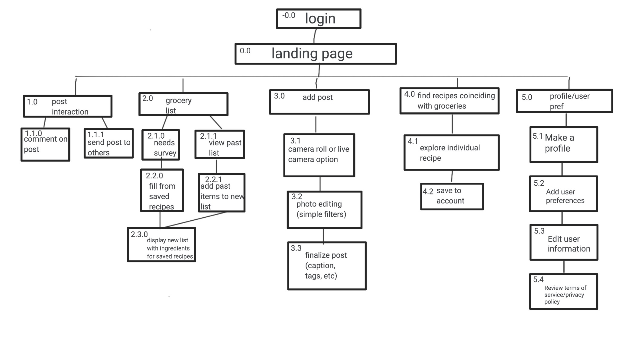

The reason we have a page before our landing page is because that will be the option to sign up /log in if the user has not used our app before. If they have, then that page will be bypassed and they will be taken to the landing page. Our landing page is a social media-esque page where you can see posts from other users talking about recipes that they’ve created and enjoyed. Off of the landing page, you have the option to interact with posts if you care to, allowing you to like or comment on posts (1.0, 1.1.0, 1.1.1). the next option on the menu bar is to create a grocery list (2.0). if you want to create a new grocery list, you will be prompted to answer a questionnaire. If you want to view past grocery lists, that will be a separate button to press. With either option, you can choose to add or remove items from the recommended grocery list, as well as check off the items as you are buying them throughout the store. In the center of the menu bar, there will be an option to add a post (3.0). Here, the user can upload photos or videos, edit their images, and add captions/ tags/ hashtags to their post in order to share their favorite recipes in a post. (3.1, 3.2, 3.3). The next item in the menu bar will bring the user to a page where they can find recipes with the ingredients they have (4.0). Here, they will be able to scroll through options, as well as search recipes they are craving. The app will specify if they have the ingredients on hand or not, so that it is easy for the user to know what they have to go out and buy before cooking. Lastly, the user will be able to access their own profile, as well as any user preferences (light/dark mode, email, push notifications, etc.) (5.0).